

SESSION 2022-23

SUBJECT:-

WEB TECHNOLOGIES

& E-COMMERCE

**PROJECT** **WORK**

SUBMITTED TO:

MRS. SHILPA BAHL

COURSE: BCA SEM 3RD

ROLL NO:-

41221131, 41221139, 41221175, 41221146

SUBMITTED BY:-

RITIK KUMAR, SACHIN RAJBHAR, KARMVIR, SANCHIT KELKAR

**CERTIFICATE**

It is hereby to certify that the original and genuine investigation work has been carried out to investigate about the subject matter and the related data collection has been completed by **Group-14** of course **BCA** in **DSEU Dwarka Campus** Regarding with the topic of **Restaurant Feedback FORM with VALIDATION** using **HTML , CSS and PHP**.

**TEACHER’S SIGNATURE EXAMINER SIGNATURE**

# ACKNOWLEDGEMENT

### The successful completion of any task would be incomplete without mentioning the names of those persons who helped to make it possible. I take this opportunity to express my gratitude in few words and respect to all those who helped in the completion of this project.

* I would like to thank my WEB TECHNOLOGIES & E-COMMERCE teacher MS. SHILPA BAHL as his constant and guidance directed me to make this project successful.

### I would like to thank my parents as their support during the completion of project really meant a lot.

* Last but not the least I would like to thank my friends as I would have not been able to complete my project without their help and support.

# PROJECT OVERVIEW

* + INTRODUCTION
  + OBJECTIVE OF THE PROJECT
  + LANGUAGES USED
  + HARDWARE AND SOFTWARE REQUIREMENTS
  + CODING OF THE PROGRAM
  + OUTPUT
  + BIBLIOGRAPHY

# Introduction

|  |  |
| --- | --- |
| Creating a Restaurant Feedback Form project is written in HTML, CSS & PHP. The project file contains Code & Output. This is a simple project which is very easy to understand and use. Talking about the system, it contains all the required functions which include adding restaurant’s feedback with some required fields (validation is applied). The webpage also shows the filled details on clicking submit button. | |
|  |  |

**Objectives of the Project**

Here are the prime objectives of this project

* Provide feedback facilities to user.
* Implement PHP which is old yet powerful.
* Use with Restaurant’s related data
* Accept User Feedback
* Validation Check in Fields
* Display the information

In addition to above primary objectives, we aim to keep the project’s complexity to the lowest level possible, so that the operator of the software can carry out all the operators with ease.

# LANGUAGES USED

* + HTML(Hypertext Markup Language)

HTML is the language for describing the structure of Web pages. HTML gives authors the means to: **Publish online documents with headings, text, tables, lists, photos, etc.** **Retrieve online information via hypertext links, at the click of a button**.

* + CSS (Cascading Style Sheets)

CSS (Cascading Style Sheets) is used **to style and layout web pages** — for example, to alter the font, color, size, and spacing of your content, split it into multiple columns, or add animations and other decorative features.

* + PHP (Hypertext PreProcessor)

PHP(short for Hypertext PreProcessor) is the most widely used open source and general purpose server side scripting language used mainly in web development **to create dynamic websites and applications**.

**Software and Hardware Requirements**

The software being developed in Python programming language scores high in portability, i.e. runs on almost all different types of computers with any operating system.

#### Software Requirements

* + - Operating Systems: Windows, Linux, Macintosh
    - Latest Vs Code extensions & compilers or any other supported IDE

#### Hardware requirements

Any computer capable of running above mentioned software can run our program. We tested our program in following hardware configurations:

* + - Processor: Intel, AMD
    - Ram: 2GB, 4GB, 8GB
    - Hard Disk: 80 GB, 160 GB, 500 GB, 1 TB
    - Keyboard, Mouse: Wired or Wireless
    - Monitor: 14 inch or above VGA or HDMI



SOURCE CODE OF PROGRAM



RESTAURANT.HTML

<!DOCTYPE html>

<html lang="en">

<head>

<meta charset="UTF-8">

<meta http-equiv="X-UA-Compatible" content="IE=edge">

<meta name="viewport" content="width=<a>, initial-scale=1.0">

<title>Restaurant </title>

<link rel="stylesheet" href="restaurant.css">

</head>

<body >

<p>

<div class="div1">

<div class="div2">

<h1 ><u>FOOD HUB</u></h1>

</div>

<marquee scrollamount="25"> <p class="p1"> Restaurant Feedback Form<p> </marquee>

<form action="restaurant.php" method="POST">

<!-- <label >Name</label> <br> -->

<pre>

<label > <span class="d"> First Name: </span><span class="required">*</span></label><input class="name1" type="text" name="firstname" placeholder="First Name" required/> <br>

<label ><span class="d"> Last Name: </span><span class="required">*</span></label><input class="name1" type="text" name="lastname" placeholder="Last Name" required/><br />

<label ><span class="d"> Email: </span><span class="required">*</span></label><input class="email" type="email" name="email" placeholder="Email" required/><br />

<label ><span class="d"> Contact: </span> <span class="required">*</span></label><input class="contact" type="mobile" name="contact" placeholder="Phone" required/> <br />

<label ><span class="e">Gender: </span><span class="required">*</span></label>

<P class="G1">Male</P>

<input type="radio" name="gender" class="gender1 gender" id="male" value="Male" required>

<P CLASS="G1">Female</P><input type="radio" name="gender" class="gender2 gender" id="female" value="Female" required>

</span>

<br />

<label ><span class="d"> Address: </span><span class="required">*</span></label><input class="address" type="textarea" name="address" placeholder="Address" required/>

<table>

<h3 class="a"><span class="required">*</span> <span> Tell us about your Experienece with our restaurant</span></h3>

<tr >

<th class="c">......Questions......</th>

<th class="c">Strongly Agree</th>

<th class="c">Agree</th>

<th class="c">Disagree</th>

<th class="c">Strongly Disagree</th>

</tr>

<tr >

<td class="b">The Menu was affordable </td>

<td><input type="radio" name="ques2" class="ques" value="Strongly Agree" required></td>

<td><input type="radio" name="ques2" class="ques" value="Agree" required></td>

<td><input type="radio" name="ques2" class="ques" value="Disagree" required></td>

<td><input type="radio" name="ques2" class="ques" value="Strongly Disagree" required></td>

</tr>

<tr>

<td class="b">Food is delecious .</td>

<td><input type="radio" name="ques3" class="ques" value="Strongly Agree" required></td>

<td><input type="radio" name="ques3" class="ques" value="Agree" required></td>

<td><input type="radio" name="ques3" class="ques" value="Disagree" required></td>

<td><input type="radio" name="ques3" class="ques" value="Strongly Disagree" required></td>

</tr>

<tr >

<td class="b"> Serving staff work satisfactory . </td>

<td><input type="radio" name="ques4" class="ques" value="Strongly Agree" required></td>

<td><input type="radio" name="ques4" class="ques" value="Agree" required></td>

<td><input type="radio" name="ques4" class="ques" value="Disagree" required></td>

<td><input type="radio" name="ques4" class="ques" value="Strongly Disagree" required></td>

</tr>

<tr >

<td class="b">Populr payment option are available. </td>

<td><input type="radio" name="ques5" class="ques" value="Strongly Agree" required></td>

<td><input type="radio" name="ques5" class="ques" value="Agree" required></td>

<td><input type="radio" name="ques5" class="ques" value="Disagree" required></td>

<td><input type="radio" name="ques5" class="ques" value="Strongly Disagree" required></td>

</tr>

<tr >

<td class="b">Do you recommend us to your friends.</td>

<td><input type="radio" name="ques6" class="ques" value="Strongly Agree" required></td>

<td><input type="radio" name="ques6" class="ques" value="Agree" required></td>

<td><input type="radio" name="ques6" class="ques" value="Disagree" required></td>

<td><input type="radio" name="ques6" class="ques" value="Strongly Disagree" required></td>

</tr>

<tr>

<td class="b">How much you satisfied with our Delivery service .</td>

<td><input type="radio" name="ques7" class="ques" value="Strongly Agree" required></td>

<td><input type="radio" name="ques7" class="ques" value="Agree" required></td>

<td><input type="radio" name="ques7" class="ques" value="Disagree" required></td>

<td><input type="radio" name="ques7" class="ques" value="Strongly Disagree" required></td>

</tr>

<tr >

<td class="b">Helpful for special abled peoples . </td>

<td><input type="radio" name="ques8" class="ques" value="Strongly Agree" required></td>

<td><input type="radio" name="ques8" class="ques" value="Agree" required></td>

<td><input type="radio" name="ques8" class="ques" value="Disagree" required></td>

<td><input type="radio" name="ques8" class="ques" value="Strongly Disagree" required></td>

</tr>

</table>

<div id="divone">

<h3 class="b">What were the most delicious foods you like in our restaurant?</h3>

<input class="divone"type="textarea" name="ques9" id="" placeholder="Maximum 200 characters allowed" required>

<h3 class="b">What changes should be made to make menu more interesting ?</h3>

<input class="divone" type="textarea" name="ques10" id="" placeholder="Maximum 200 characters allowed" required>

<h3 class="b">What additional information would you want to tell us </h3>

<input class="divone" type="textarea" name="ques11" id="" placeholder="Maximum 200 characters allowed" required>

<h3 class="b">Additional comments:</h3>

<input class="divone" type="textarea" name="ques12" id="" placeholder="Maximum 200 characters allowed" required>

<input type="submit" name="submit" Value="Submit" id="btn">

</div>

<img src="RES.jfif" alt="RESTAURANT IMAGE " class="img">

</form>

</div>

</div>

</div>

</body>

</html>

RESTAURANT.CSS

.maindiv {

margin:auto;

width: 980px;

height:700px;

padding-top:20px;

font-family:'Segoe UI', Tahoma, Geneva, Verdana, sans-serif;

font-size: larger;

}

div2{

    font-family:nova;

    font-size: 35px;

}

h1{

font-family:'Franklin Gothic Medium', 'Arial Narrow', Arial, sans-serif;

text-align: center;

margin:auto;

color: #ff0000;

font-style: italic;

font-size:150px;

}

.title {

width:500px;

height:70px;

text-shadow:2px 2px 2px #cfcfcf;

font-size:16px;

text-align:center ;

}

.form_div {

width: 500px;

margin: auto;

float:auto ;

}

form {

width:auto;

height: auto;

border:1px dashed rgb(200, 0, 0);

padding:10px 30px 40px;

margin: auto;

background-color:#fce90f;

}

form h2 {

text-align:center;

text-shadow:2px 2px 2px #f10f0f ;

margin: auto;

}

input[type=textarea]{

    width: 40%;

    height:4cm;

border-radius:1px;

font-size: 50PX;

font-family: 'Lucida Sans', 'Lucida Sans Regular', 'Lucida Grande', 'Lucida Sans Unicode', Geneva, Verdana, sans-serif;

font-weight: 700;

box-shadow:0 0 1px 2px #1ea55b;

margin-top:10px;

padding:10px;

border:none;

}

p{

color:rgb(5, 2, 223);

text-align:center ;

font: size 40px;

font-style: oblique;

font-family:'Trebuchet MS', 'Lucida Sans Unicode', 'Lucida Grande', 'Lucida Sans', Arial, sans-serif

}

span {

text-align:center;

color:#0d57f8;

font-size:50px;

}

body{

    background-color: #a0e3cf;

    text-align: center;

}

marquee{

    font-size: 80px;

}

.res{

    color: #000000;

    font-size: 50px;

    font-style: italic;

    font-family: Impact, Haettenschweiler, 'Arial Narrow Bold', sans-serif;

}

img{

    height: 800px;

    width: 1200px;

}

.a{

    text-decoration: wavy;

    color: #ff0000;

    font-size:50px;

    text-decoration: solid;

}

table{

    margin-left:24%;

}

.required {

    color: red;

  }

.d{

    font: size 20%;;

    color: #0d57f8;

}

.b{

    font-family: Arial, Helvetica, sans-serif;

    font-size:30px;

    color: #0d57f8;

}

.c{

    font-family: Arial, Helvetica, sans-serif;

    font-size:40px;

    color: #000000;

}

input[type="radio"] {

    width: 100%;

    background-color: #0000dc;

    color: rgb(227, 38, 38);

    padding: 14px 20px;

    margin-top: 2%;

    margin-left: 1%;

    border-color:red;

    border-radius: 5px;

    cursor: pointer;

    height: 3em;

    width:8em;

    font-size:30px;

  }

.G1{

    color: #000000;

    font-size:40px;

    padding-right:13%;

}

input[type="radio1"] {

    width: 100%;

    background-color: #0000dc;

    color: rgb(227, 38, 38);

    padding: 14px 20px;

    margin-bottom:17%;

    margin-left: 1%;

    border-color:red;

    border-radius: 5px;

    cursor: pointer;

    height: 3em;

    width:8em;

    font-size:30px;

  }

input[type="submit"] {

    width: 100%;

    background-color: #0000dc;

    color: white;

    padding: 14px 20px;

    margin-top: 2%;

    margin-left: 1%;

    border: none;

    border-radius: 4px;

    cursor: pointer;

    height: 10em;

    width:8em;

    font-size:30px;

  }

  input[type="text"], select, textarea {

    width: 40%;

    height:4cm;

    font-size: 40px;

    font-weight: 700;

    padding: 20x;

    margin:auto;

    border: 1px solid #ccc;

    border-radius: 4px;

  }

  input[type="email"], select, textarea {

    width: 40%;

    height:4cm;

    padding: 20x;

    font-size: 40px;

    font-weight: 700;

    margin-bottom: 20px;

    border: 1px solid #ccc;

    border-radius: 4px;

    box-sizing: border-box;

  }

  input[type="mobile"], select, textarea {

    width: 40%;

    height:4cm;

    padding: 20x;

    font-size: 40px;

    font-weight: 700;

    margin-bottom: 20px;

    border: 1px solid #ccc;

    border-radius: 4px;

    box-sizing: border-box;

  }

  pre{

    text-align: justify;

  }

RESTAURANT.PHP

<html>

<head>

<title>PHP SERVER</title>

<link rel="stylesheet" href="restaurant.css">

</head>

<body class="res">

<pre>

<?php

$server="localhost";

$username = "root";

$password = "";

$dbname = "register";

$con= mysqli_connect($server, $username, $password, $dbname);

if(!$con) {

//die("Connection failed: " .mysqli_connect_error());

echo "not connected ";

}

else{

echo "connected successfully";

}

$firstname ="";

$lastname ="";

$email ="";

$contact ="";

$gender ="";

$address="";

if (isset($_POST['submit'])) {

$firstname = $_POST['firstname'];

$lastname = $_POST['lastname'];

$email = $_POST['email'];

$contact = $_POST['contact'];

$gender = $_POST['gender'];

$address = $_POST['address'];

$ques2 = $_POST['ques2'];

$ques3 = $_POST['ques3'];

$ques4 = $_POST['ques4'];

$ques5 = $_POST['ques5'];

$ques6 = $_POST['ques6'];

$ques7 = $_POST['ques7'];

$ques8 = $_POST['ques8'];

$ques9 = $_POST['ques9'];

$ques10 = $_POST['ques10'];

$ques11 = $_POST['ques11'];

if (empty($firstname && $lastname && $email && $contact && $gender && $address)) {

echo ' <script> alert("All fields are required")</script>';

} elseif (!preg_match("/^[a-zA-Z-' ]*$/", $firstname)) {

echo ' <script> alert("Only letters and white space allowed in name")</script>';

} elseif (!preg_match("/^[a-zA-Z-' ]*$/", $lastname)) {

echo ' <script> alert("Only letters and white space allowed in name")</script>';

} elseif (!preg_match("/^[0-9]*$/", $contact)) {

echo ' <script> alert("Enter correct Phone Number \n [0-9]")</script>';

} else {

$query = "insert into restaurant (firstname, lastname, email,contact,gender,address,ques2,ques3,ques4,ques5,ques6,ques7,ques8,ques9,ques10,ques11)

VALUES ('$firstname', '$lastname', '$email','$contact','$gender','$address','$ques2','$ques3','$ques4','$ques5','$ques6','$ques7','$ques8','$ques9','$ques10','$ques11')";

$runquery = mysqli_query($con, $query);

if ($runquery) {

echo '<script>alert("New record inserted successfully!")</script>';

} else {

echo '<script>alert("Insertion Failed !!")</script>';

}

}

}

mysqli_close($con);

echo "<br>";

echo " Thank you for your Valuable feedback ";

echo "<BR>";

echo " Name is :$firstname $lastname ";

echo "<br>";

echo " email: $email";

echo "<br>";

echo " GENDER :$gender";

echo "<br>";

echo " contact :$contact";

echo "<br>";

echo " Address:$address ";

echo "<br>";

echo $ques2;

echo "<br>";

echo $ques3;

echo "<br>";

echo $ques4;

echo "<br>";

echo $ques5;

echo "<br>";

echo $ques6;

echo "<br>";

echo $ques7;

echo "<br>";

echo $ques8;

echo "<br>";

echo $ques9;

echo "<br>";

echo $ques10;

echo "<br>";

echo $ques11;

echo "<br>";

?>

</pre>

</body>

</html>

# OUTPUT

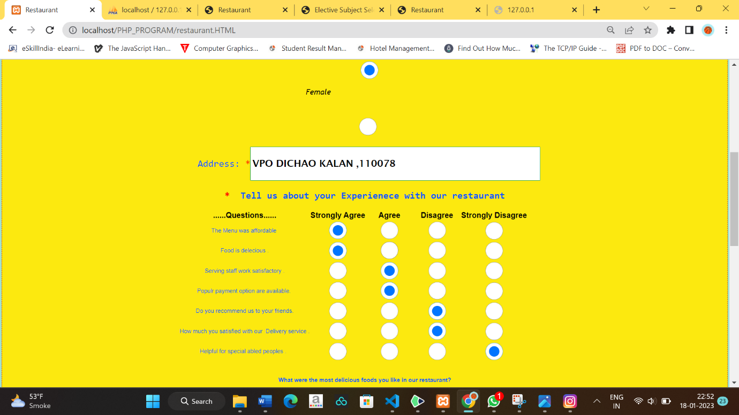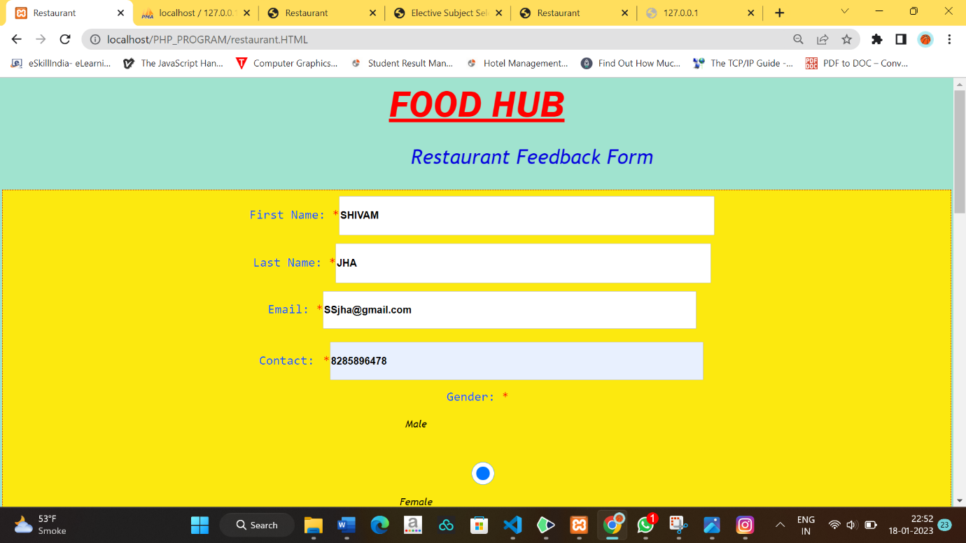

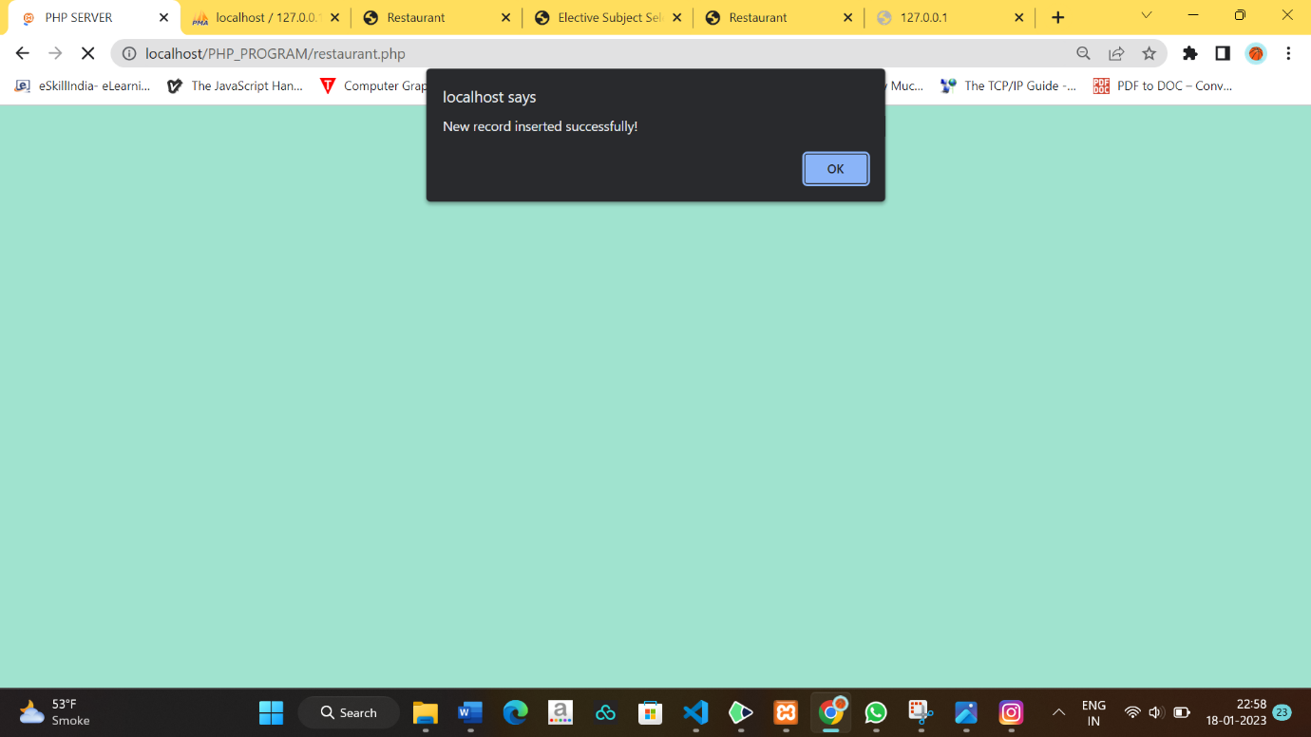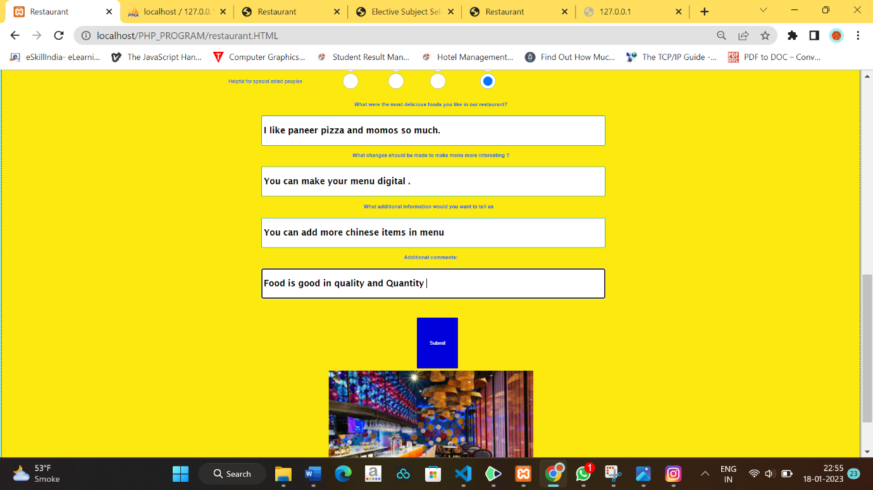

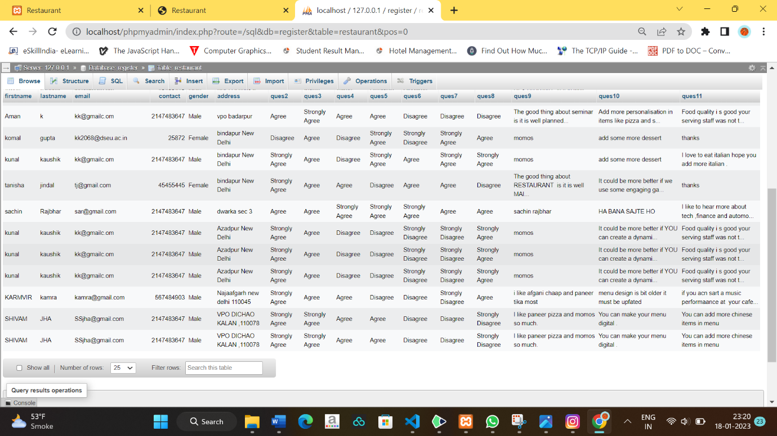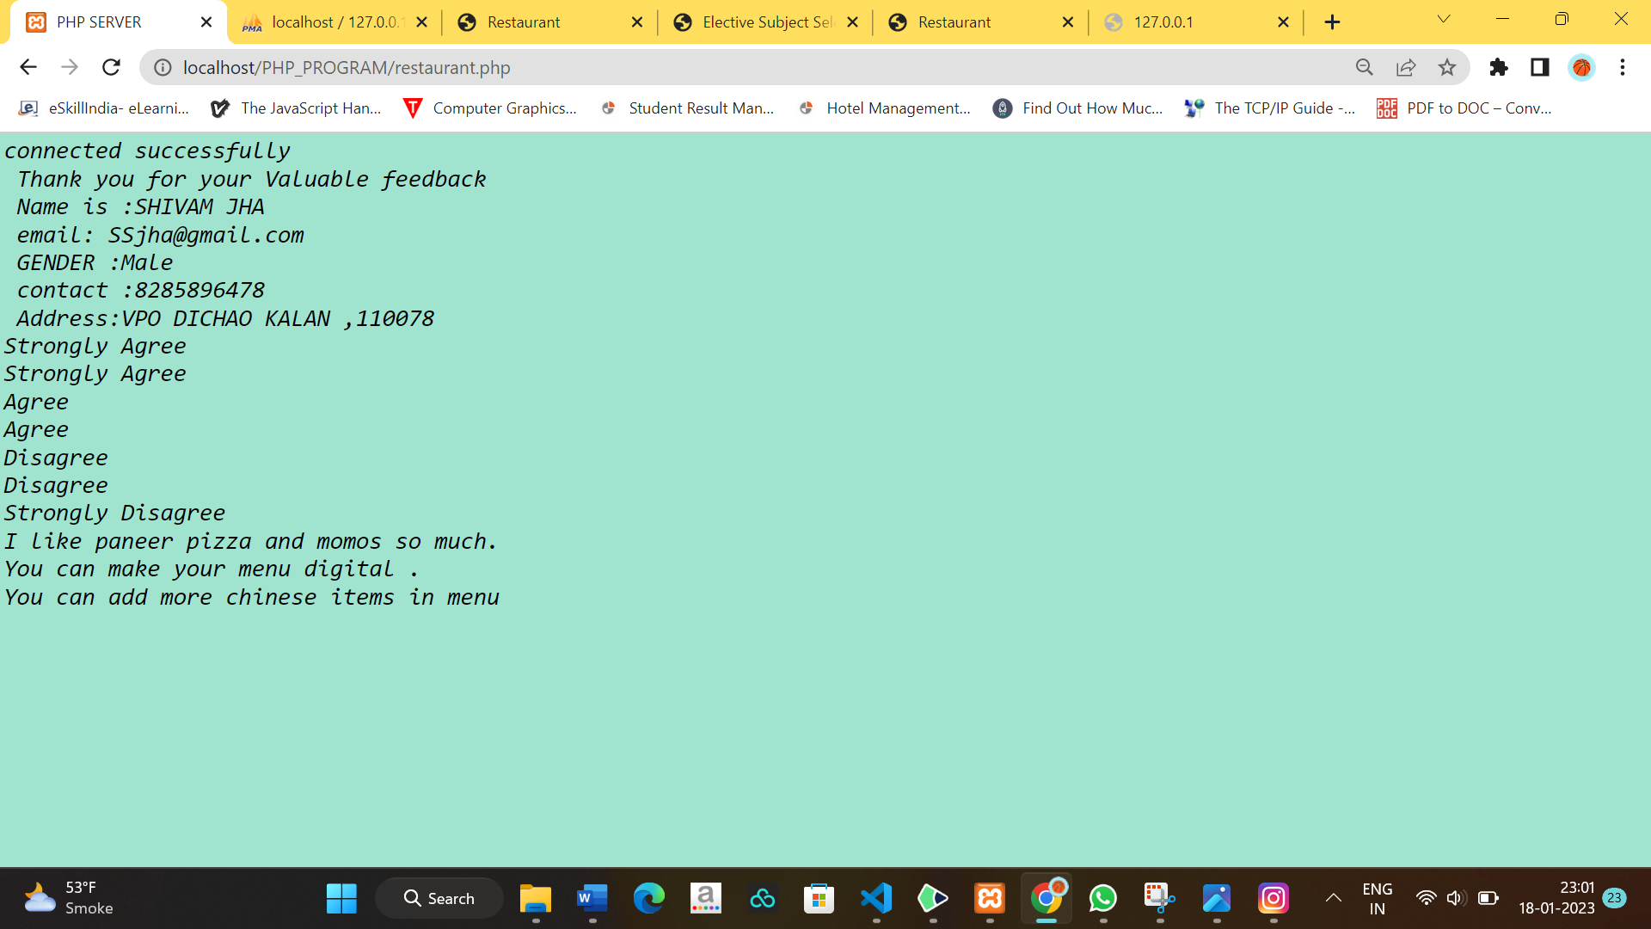

**Bibliography**

**FOR THIS PROJECT, THE FOLLOWING BOOKS WERE CONSULTED:**

## HTML AND CSS

## Prog. PHP

AND FOLLOWING SITES:

* [www.google.com](http://www.google.com/)
* [www.w3schools.com](http://www.w3schools.com/)
* [WWW.YOUTUBE.COM](http://WWW.YOUTUBE.COM/)

##### 